Smart Mart System
Architecture Driver Document
Version 0.2

History.
Version | Date | Author | Content
0.1 | 28-May-2012 | Son Dang | First version
0.2 | 29-May-2012 | Son Dang | Add QA scenario.  Fix spelling errors.  Update content table.
0.2 | 29-May-2012 | Tam Do | Add use-case diagram.  Add use-case description (in progress).

Contents
1. Introduction. 5
1.1. Purpose. 5
1.2. Intended audience. 5
1.3. Document overview. 5
1.4. Definitions, acronyms and abbreviations. 5
1.5. Reference. 6
2. Project overview. 6
2.1. Business object. 6
2.2. Scope. 6
2.3. Team process. 6
3. Functional requirement. 6
3.1. Entities description. 6
3.1.1. Manager. 6
3.1.2. Store manager. 7
3.1.3. Cashier. 7
4. Quality attributes. 9
4.1. Qualities list and priority. 9
4.2. Quality scenario. 9
4.2.1. Performance. 9
4.2.2. Availability. 10
4.2.3. Usability. 11
5. Constraints. 12
5.1. Business constraints. 12
5.2. Technical constraints. 12

Introduction.

Purpose.
This document describe the architecture driver of Smart Mart System consist of key functional requirement, quality attributes and constraint. Support for developing architect of system.
The development team can use this document to review the architecture of the system. The document will be also useful for future development teams

Intended audience.
NO | Roles | Reading suggestion
1 | Requirement develop team. | Use case, constraints
2 | Detail designer | Use case, constraints
3 | customer | Quality attributes.

Document overview.
Architecture driver document include the following parts.
- Key functional requirement. Describe the key requirement of system.
- Quality attribute. Describes quality attribute and their scenario.
- Business constraints. Describes business constraints of customer operation or team develop.
- Technical constraints. Describes technical constraints of development team.

Definitions, acronyms and abbreviations.
No | Glossary | Description
1 | QA | Quality Attribute

Reference.

Project overview.

Business object.
Develop a program can help customer manage their sale operation in store system, manage inventory, manage store’s customer and manage store’s user by using support from the computers.

Scope.
Program will help customer of store system to manage their sale operation, manage store’s customer, user and inventory.

Team process.
Described in team process document.

Functional requirement.

Entities description.
NO | Entity
1 | Manager
2 | Store manager
3 | Cashier

Manager.
Manager is the person or a group have responsibility to control store system. Manager have permission to:
- Manage system user include cashier account or store manager account.
- Manage store inventory include create new product, edit product, delete product, edit general product price.
- Manage store include create new store, add product to store, remove product from store, collect and read report from store.

Store manager.
Store manager is the person has responsibility to control local store operation.
Store manager has permission to:
- Manage local store user under Store manager control, cashier account.
- Manage sale report.
- Manage local price of product.
- Manage store’s customer include create new customer, edit customer, disable and enable customer.

Cashier.
Cashier is group of account have responsibility to operate sale activities.
  - Use case diagram and description.
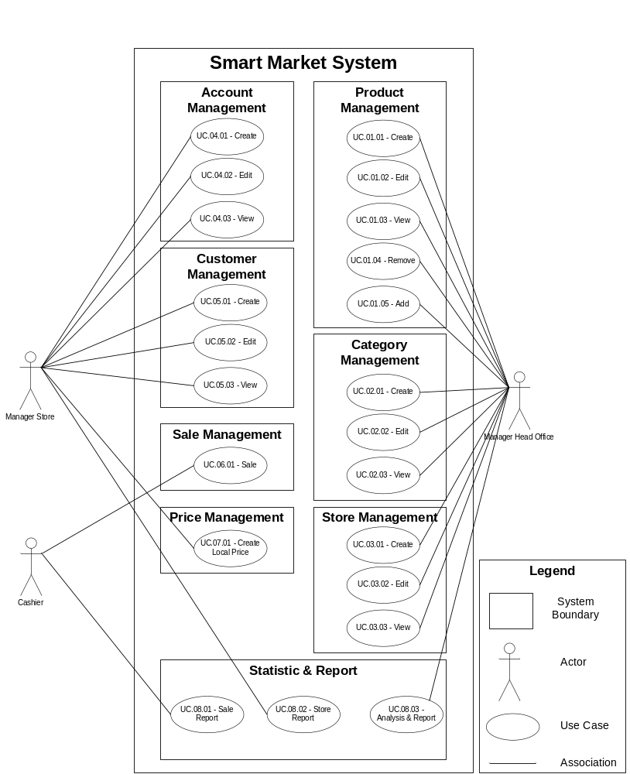

Quality attributes.

Qualities list and priority.
ID | Quality attribute | Priority | overview
QA1 | Performance | High | First criteria: FAST AND FAST
QA2 | Availability | High | First criteria: NEVER DOWN
QA3 | Usability | High | First criteria: CAN USE ON ALL BROWERS

Quality scenario.

Performance.
Performance Scenario. The system execute operation immediately
Portion of scenario | Possible value
Source | Store manager – Manager
Stimulate | Make random 100 operation (add product, remove product … etc)
Artifact | System
Environment | System operating environment (runtime) – normal mode
Response | Show notification that “ operation execute successful” after each command.
Response measure | Average time of each operation must less than 3 seconds.

Performance Scenario. Display information immediately
Portion of scenario | Possible value
Source | All user.
Stimulate | Access random data (show list of product, list of customer, access customer information … etc)
Artifact | System
Environment | System operating environment (runtime) – normal mode
Response | System will show all information of access input.
Response measure | Average time of each operation and show information must less than 5 seconds.

Performance Scenario. Number of successful transactions for at least in one second
Portion of scenario | Possible value
Source | Cashiers
Stimulate | Make random 10 transactions per second.
Artifact | System
Environment | System operating environment (runtime) – normal mode
Response | Notify that transaction successfully.
Response measure | Number of successful transactions for at least in one second must more than 10 transactions.

Availability.
Availability Scenario. Ensure system operate constantly.
Portion of scenario | Possible value
Source | External, internal
Stimulate | Turn off database or web server. Database down or web server down.
Artifact | System
Environment | System operating environment (runtime) – normal mode
Response | System switch to use backup database and backup web server when problem occur.
Response measure | Time delay when problem occur less than 30 second.

Usability.
Usability Scenario. Easy to deploy in any system.
Portion of scenario | Possible value
Source | Developer
Stimulate | Sign in and use random feature on client using Chrome, IE, Firefox and Safari browser.
Artifact | System
Environment | System operating environment (runtime) – normal mode
Response | The system feature can be used in client browser.
Response measure | Program is deployed at head office and the features of system can be used on any browser.

Constraints.

Business constraints.
NO | Content | Constraint
1 | Schedule | Develop in about 1 month.
2 | Team members | 5 people.

Technical constraints.
NO | Content | Constraint
1 | Platform | .NET Framework
2 | Develop method | MVC model version 3
3 | Language | C#
4 | Tool | Visual Studio 2010 SP1 Ultimate
5 | Runtime environment | Software must install in a computer and can run on any browsers.

